Setup MS Office in VM

Project statement: Setting up MS Office in VM to run barcode excel add-in test as one of the project I am involved in requires automating qr code generation based on barcodes scanned. As it is a third party add-in, sandbox testing is required so a VM was setup.

Tools used:

* ODT (download from: https://www.microsoft.com/en-us/download/details.aspx?id=49117)
* Virtualbox
* Win 11 iso

Step 1: Head to <https://www.microsoft.com/en-us/download/details.aspx?id=49117> in VM and download the office deployment tool

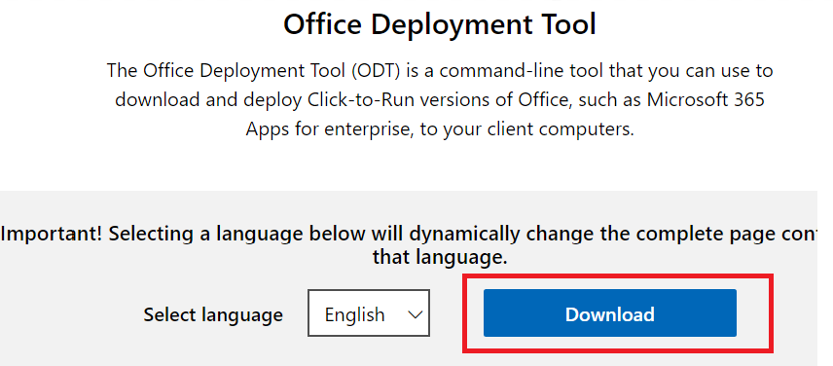

Step 2: Once downloaded, you may unzip the downloaded folder to a location you want and then the extracted files will be as below:

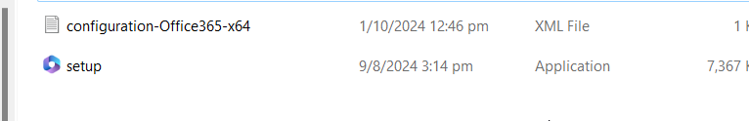

Step 3: Open the configuration-office.xml file with notepad and edit the 2 parts:

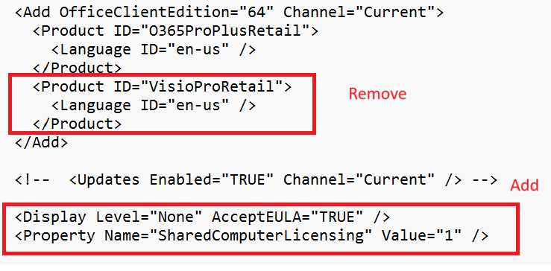

Step 4: Change directory using elevated command prompt and then run the following



Step 5: It will download in background. If you head back to the folder containing the config xml file you should see another folder appear as below.

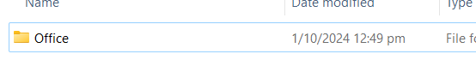

Step 6: Let it download all the way until it automatically moves to a new line in the same command prompt



Step 7: now, it is time to run the setup file based on the config xml file.



Step 8: Again, it will run in the background. Wait for it to finish

